Turn Around Time Dictation System

For questions contact Medical Records at 626-397-5054 or Transcription Assistance at 626-397-8794.

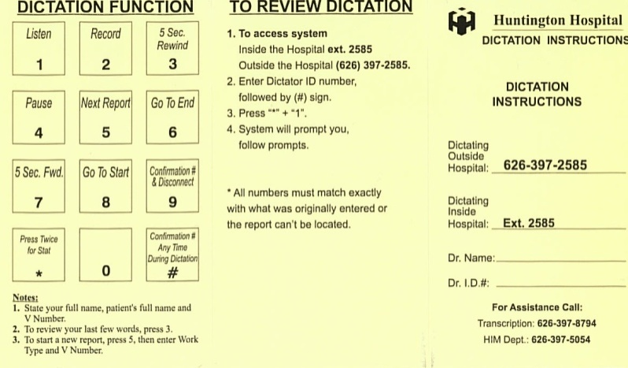
To Dictate a Report
- Dial 2585 from inside the hospital or
626-397-2585 from outside the hospital
- Enter 5 digit employee ID/dictation number then press # key
- Enter work type number, then press # key
- Enter patient visit number, then press # key

Notes:
- State your full name, patient’s full name and visit number.
- State what the date of service is/was.
- To review your last few words, press “3”.
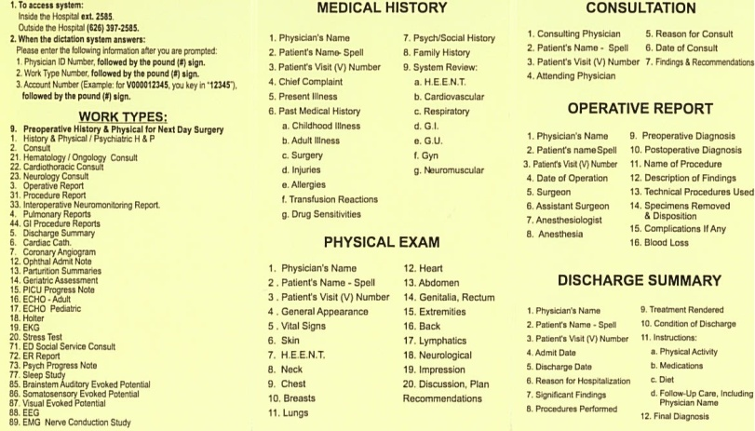
- To start a new report, press “5”, then enter Work Type and visit number.

To Review Dictation
- Dial 2585 from inside the hospital or
626-397-2585 from outside the hospital
- Enter 5 digit employee ID/dictation number, then press # key.
- Press “*” + “1”
- System will prompt you, follow prompts.

Turn Around Time Dictation System

Dictation Functions
1. Listen | 7. 5 Sec Rewind
2. Record | 8. Go To Start
3. 5 Sec rewind | 9. Confirmation # & Disconnect
4. Pause | * Press Twice for Stat
5. Next Report | # Confirmation # Any Time During Dictation
6. Go To End

Work Types

9 | Preop H&P For Next Day Surgery | 17 | ECHO - Pediatric | 77 | Sleep Study
1 | History & Physical; Psychiatric H&P | 18 | Holter | 85 | Brainstem Auditory Evoked Potential
2 | Consult | 19 | EKG | 59 | Palliative Care Progress Note
21 | Hematology/ Oncology Consult | 20 | Stress Test | 60 | Pediatric Prgress Note
22 | Cardiothoracic Consult | 34 | ECT Procedure Note | 61 | Thoracic Surgery Progress Note
23 | Neurology Consult | 86 | Somatosensory Evoked Potential | 62 | Trauma Progress Note
3 | Operative Report | 87 | Visual Evoked Potential | 63 | Urology Progress Note
31 | Procedure Report | 88 | EEG | 64 | Vascular Surgery Progress Note
33 | Interoperative Neuromonitoring Report | 89 | EMG Nerve Conduction Study | 65 | Pulmonary Progress Note
4 | Pulmonary Reports | 50 | Critical Care Progress Note | 66 | Internal Medicine Progress Note
44 | GI Procedure Reports | 51 | ENT Progress Note | 67 | Nephrology Progress Note
5 | Discharge Summary | 52 | General Surgery Progress Note | 68 | Family Practice Progress Note
6 | Cardiac Cath | 53 | Hem/Oncology Progress Note | 69 | Cardiology Progress Note
7 | Coronary Angiogram | 54 | Hospitalists Progress Note | 70 | Ophthalmology Progress Note
12 | Ophthalmology History & Physical | 55 | Neurology Progress Note | 73 | PPR-HMH Psychiatric Progress Note
13 | Parturitiion Summaries | 56 | Neurosurgical Progress Note | 73 | PPR-HMH Psychiatric Progress Note
14 | Geriatric Assessment | 57 | OB/GYN Progress Note | 74 | Infectious Disease Progress Note
15 | PICU Progress Note | 58 | Orthopedic Progress Note | 75 | GI Progress Note
16 | ECHO - Adult | 72 | ED Report (STAT < 2 Hours)

