Huntington Hospital CDI Program

Clinical documentation improvement (CDI) is pivotal in determining and supporting medical necessity. Clinical Documentation Improvement Specialists (CDIS) review the patient record and provide feedback in the form of a written query. We query for clarification of diagnosis, of conflicting or ambiguous documentation, further specificity, and documentation of a diagnosis based on clinical indicators.

The queries are designed to ensure that all documentation is of high quality and paints a true picture of the care being provided to the patient. The queries at Huntington can be found in Cerner’s Message Center.

The CDIS will collaborate with physicians to ensure complete and concise documentation that assists in the capture of severity of illness (SOI), risk of mortality (ROM) and improve patient quality of care.

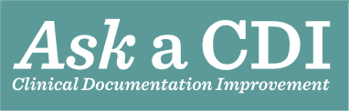

The CDI team is here to assist you with your documentation needs. Please feel free to call us if you have any questions at ext. 3662.
Individual CDIS can be reached at the following extensions:

Karen Beal, RN, BSN, CCDS, ext. 2024
Maria Gilda Villanueva, CCDS, ext. 3665
Theresa Cardona, RN, CCDS, ext. 3787
Mariz Fogata, RN, ext. 3162

